Rally News
On behalf of the organising committee, Welcome to the start of another AHCCNZ National Rally adventure. The Wellington members are pleased to announce the next biennial National Rally will be held in Palmerston North, Manawatu, from the 28th-31st March 2019.
The Manawatu is renowned for its power generation using clean green New Zealand wind. The hills surrounding Palmerston North are dotted with wind turbines to the north and south of the Manawatu Gorge. These iconic structures stand tall atop the hillside, making a striking statement on the landscape due to their size and the number of turbines visible along the eastern skyline.
So in recognition of the Manawatu landscape, the 2019 AHCCNZ National Rally in Palmerston North is aptly named the “Windmill Rally”
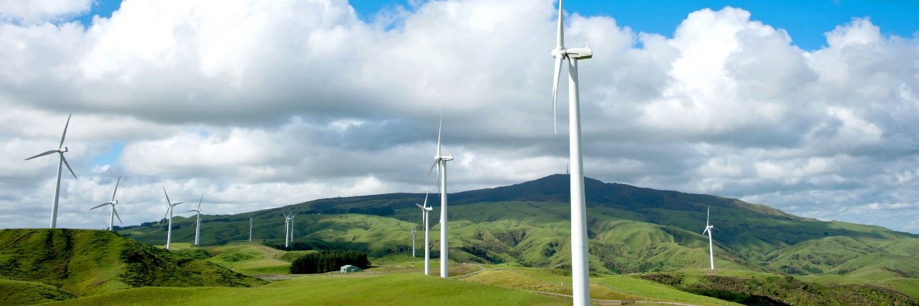
Palmerston North is a great place to hold a rally being equidistant from both Auckland and Christchurch. The city is a thriving hub, supporting large organisations such as Massey University, Toyota New Zealand and a large rural community. To get a feel of the vibe of Palmerston North checkout this short video about Palmerston North
The Windmill Rally accommodation and conference venue will be at the Hotel Coachman, located 5 minutes walking distance from the Palmerston North CBD.
The Coachman has a range of room sizes and room rates, which the organising committee have negotiated at a reduced rate for the Rally. The room rates will be sent out once the rally registration packs are finalised. You’ll be pleased to know we have arranged secured underground parking at the hotel for the duration of the rally. Check out the Hotel Coachman to see what the hotel has to offer.
The Rally organising committee have been busy planning a fantastic Rally. You’ll get to meet up with your fellow AHCCNZ friends, enjoy magnificent company and see some of the fantastic scenery the Manawatu and surrounding districts has to offer. Of course there will be the traditional rally favourites such as a grass gymkhana, Austin-Healey concours and several organised rally runs, all competing for the right to have your name against the prestigious AHCCNZ trophies up for grabs.
You’ll hear from us!
As we continue to finalise the Rally programme we’ll keep you up to date on progress along the way via regular updates in Healey Torque and on our dedicated Windmill Rally webpage.
CHEERS…………Paul Johnson and the Windmill Rally Organising Committee



Austin-Healey Car Club of New Zealand 2019 Windmill Rally
- 28th-31st March 2019
- Palmerston North, Manawatu

- Accommodation -Hotel Coachman, Palmerston North
- Information - AHCCNZ Windmill Rally webpage

