
Windmill Rally Webpage
Rally Registration Form

Windmill Rally, 28th-31st March 2019 – Update#2

As promised in our first Windmill Rally update you would hear from us as we get closer to the Rally. Over the last few months the committee has taken the building blocks of the Windmill Rally program and have been finalising the little details for each part of the Rally.

With less than 190 days to the Rally it’s time to ensure your calendar is free, fill out and send us your Rally registration and book your accommodation. A big thank you to those who have already registered. Check out the Windmill Rally webpage which has all the details of the Rally and also a countdown timer running down to the Rally start date of 28th March 2019. If you have misplaced the registration form we sent you it can be downloaded directly from the webpage or the link above. All the registration details are on the form.

The Rally committee have had a few questions from some very keen South Islanders (I believe they call it the Mainland?) asking about a travel subsidy for those members traveling across the strait. We are currently looking into applying the travel subsidy for the Windmill Rally. As soon as a decision is finalised we will advise via our next update. We hope to see many of you travel up next year as there’s some of you I haven’t met yet, (Diane Nelligan).

Another question was whether there was going to be an AGM held at the Rally. This was discussed at the last AGM and the question on whether an AGM is going to be held at the Windmill Rally is currently with the National Executive. We will let everyone know once the decision is finalised.

The Rally run on the Friday has a lunch stop planned at the Mangatainoka Tui Brewery with lunch included as part of the rally fee. After lunch there are two options, either stay for a tour of the brewery (additional $25 at your cost) and return to Palmerston North later in the day, or following lunch continue on with the remainder of the Friday run around the area, returning back to Palmerston North. Full directions will be supplied on the day.

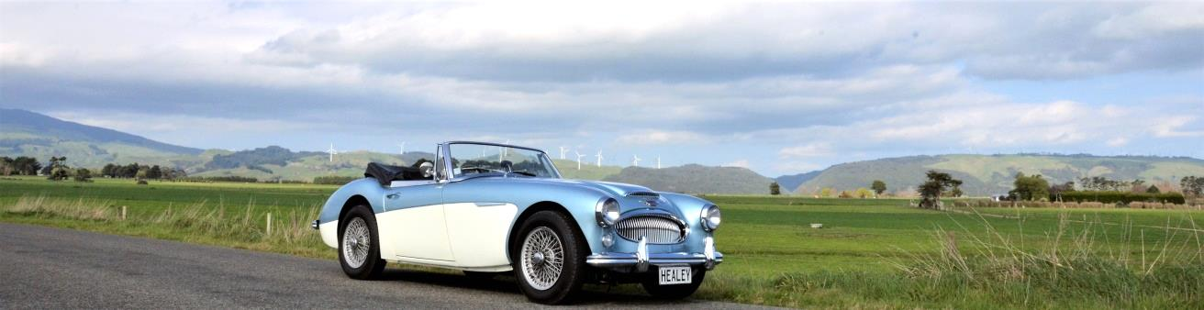

Anyhow, that’s enough of what the Rally Committee has been up to. Now for what you need to be up to over the coming months.

The theme for the 2019 Rally is Windmills however the theme for the Saturday night prize giving is Smugglers and Pirates of Perranporth Cornwall. For those who didn’t know, Perranporth Cornwall was the birth place of Donald Healey who also opened the first garage in the town in 1919. However history shows Perranporth Cornwall was infamous for being inundated with smugglers and pirates around them there parts! AARRHH. We suggest you get googling for some pirate or smuggler ideas so you’ve got time to get the costume perfected (No live parrots or budgee smugglers allowed!!)
This year the Rally organising committee may be small in number but we are big on commitment to ensure you will thoroughly enjoy the events we have planned for you in the Manawatu as part of the Windmill Rally 2019. Until our next update………. Remember to Register, Book accommodation and get googling!
Paul Johnson and the 2019 Windmill Rally Organising Committee

